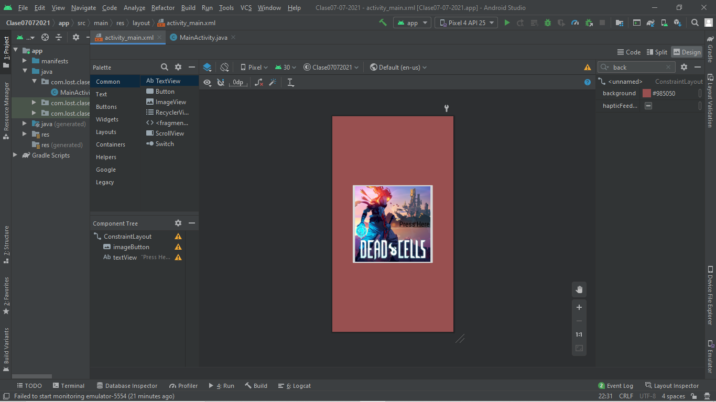
//CODIGO
package com.lost.clase07_07_2021;
import androidx.appcompat.app.AppCompatActivity;
import android.content.Intent;
import android.net.Uri;
import android.os.Bundle;
import android.view.View;
public class MainActivity extends AppCompatActivity {
@Override
protected void onCreate(Bundle savedInstanceState) {
super.onCreate(savedInstanceState);
setContentView(R.layout.activity_main);
}
public void shareLink(View view){
Uri uri = Uri.parse("https://dead-cells.com/");
Intent intent = new Intent(Intent.ACTION_VIEW, uri);
startActivity(intent);
}
}

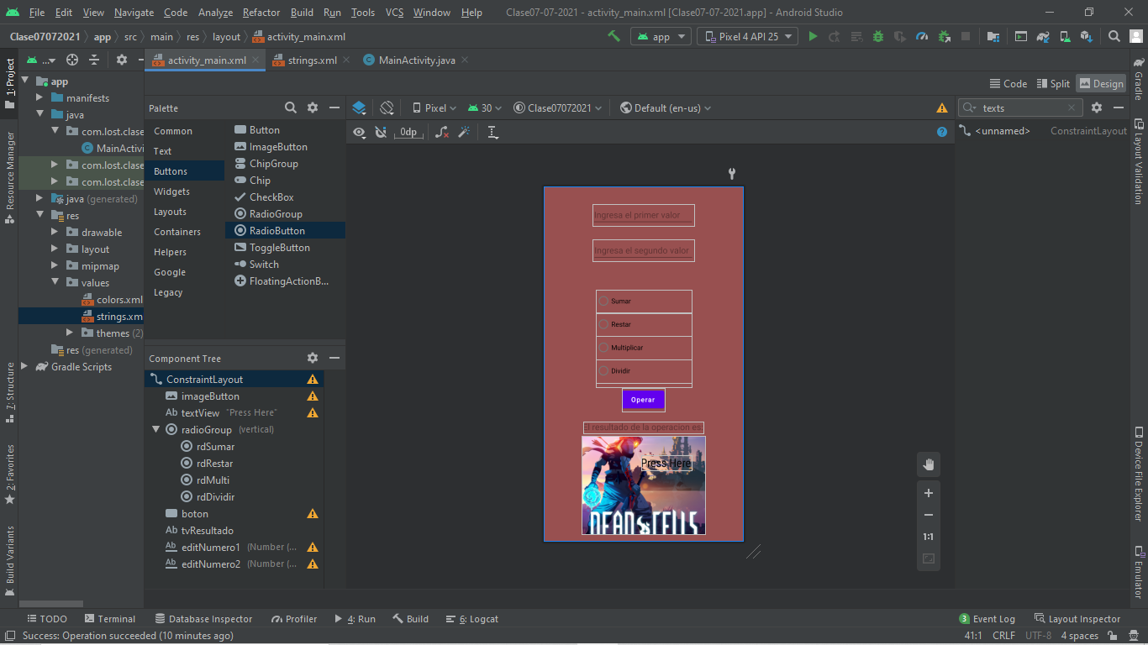
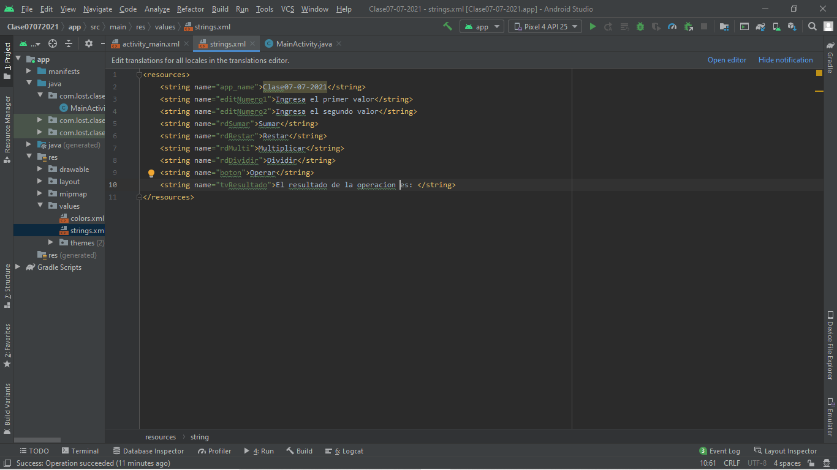
//CODIGO
package com.lost.clase07_07_2021;
import androidx.appcompat.app.AppCompatActivity;
import android.content.Intent;
import android.net.Uri;
import android.os.Bundle;
import android.view.View;
import android.widget.EditText;
import android.widget.RadioButton;
import android.widget.TextView;
import android.widget.Toast;
public class MainActivity extends AppCompatActivity {
private EditText ed1, ed2;
private TextView tv1;
private RadioButton rbSumar, rbRestar, rbMulti, rbDividir;
@Override
protected void onCreate(Bundle savedInstanceState) {
super.onCreate(savedInstanceState);
setContentView(R.layout.activity_main);
ed1 = findViewById(R.id.editNumero1);
ed2 = findViewById(R.id.editNumero2);
tv1 = findViewById(R.id.tvResultado);
rbSumar = findViewById(R.id.rdSumar);
rbRestar = findViewById(R.id.rdRestar);
rbMulti = findViewById(R.id.rdMulti);
rbDividir = findViewById(R.id.rdDividir);
}
public void operar(View view){
int valor1 =Integer.parseInt(ed1.getText().toString());
int valor2 = Integer.parseInt(ed2.getText().toString());
float resultado = 0f;
if(rbSumar.isChecked()){
resultado = valor1 + valor2;
}
else if(rbRestar.isChecked()){
resultado = valor1 - valor2;
}
else if(rbMulti.isChecked()){
resultado = valor1 * valor2;
}
else if (rbDividir.isChecked()){
if(valor2==0)
Toast.makeText(this, "No se puede dividir por 0", Toast.LENGTH_LONG).show();
else
resultado = valor1 / valor2;
}
tv1.setText("El resultado de la operacion es: " + resultado);
}
public void shareLink(View view){
Uri uri = Uri.parse("https://dead-cells.com/");
Intent intent = new Intent(Intent.ACTION_VIEW, uri);
startActivity(intent);
}
}

